REGISTERING FOR A SQUASH LEVELS ACCOUNT (ARMY SQUASH PLAYERS)

LIMITED TIME OFFER - FREE Premium (Platinum Level) Squash Levels account for Army
Squash Players

To Register (new member)

Step 1 - Go to following SquashLevels registration page (check that you see the Army Squash - Logo in the top right) and CREATE ACCOUNT

Step 2 - Enter Personal Details and Create a Password (6 characters minimum),
Tick that you have read Terms of Service and Info notifications (optional) and
SUBMIT

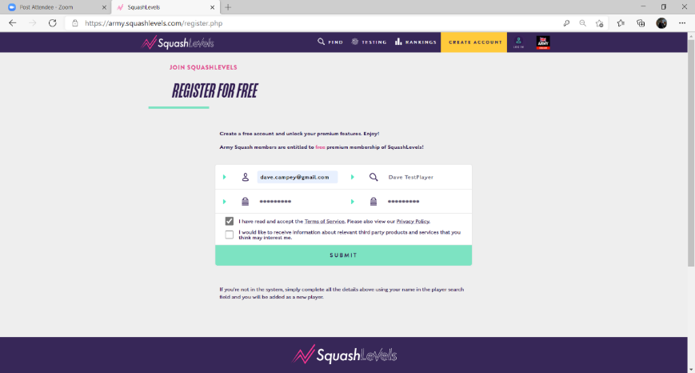

If an existing member then you will need to update your membership profile and
you will see this alternative screen or your dashboard.

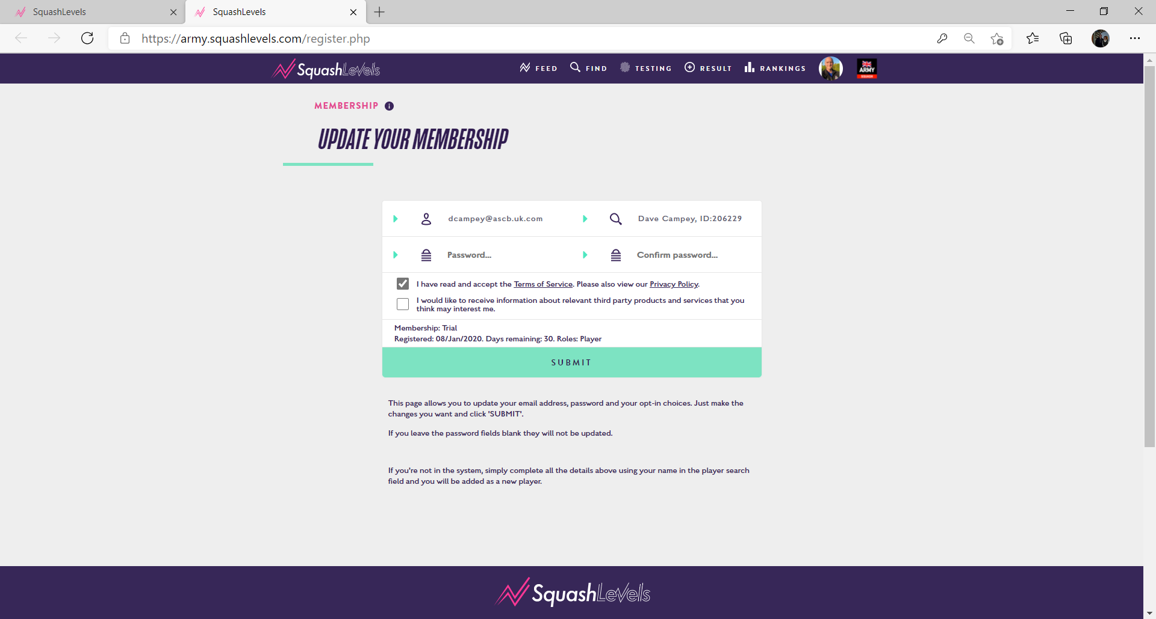
Edit profile by clicking on photo and then the ellipsis (…) see final diagram
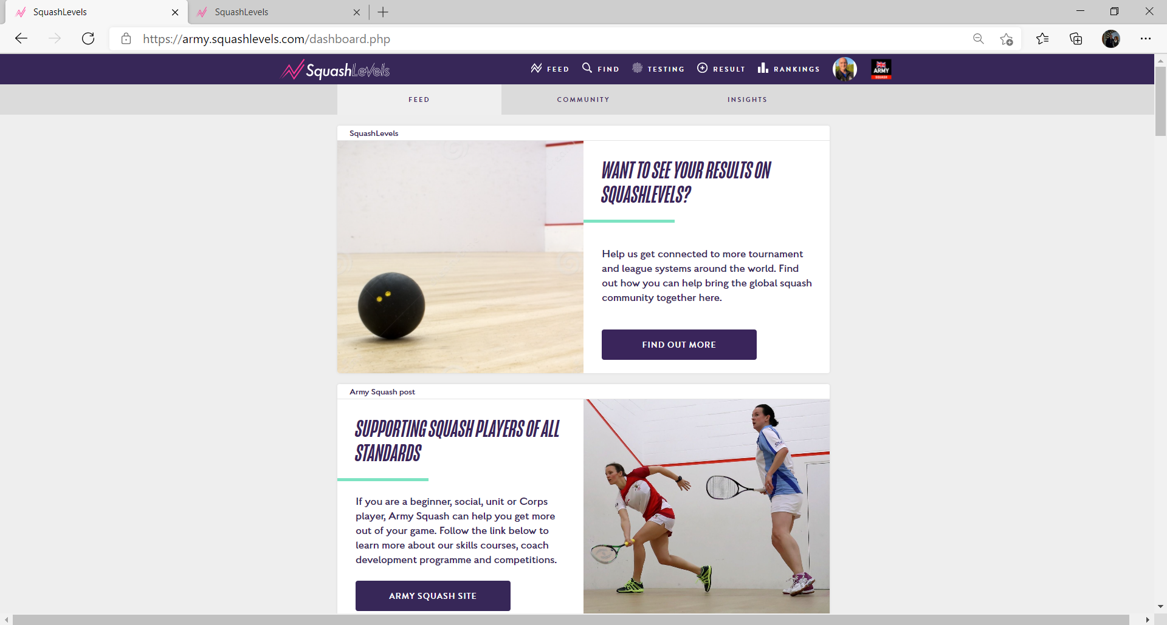

Step 3 – Complete/Update Profile - your ZAP number is first two letters of SURNAME and the last 4 of your Regimental Number combined (e.g. CA1234) this will give you access to Army Community and FREE Platinum membership. Add your ES membership number if you have one. Only add Club and County if you are a member of a civilian squash club.
Fill in Country as ENG - England. SAVE

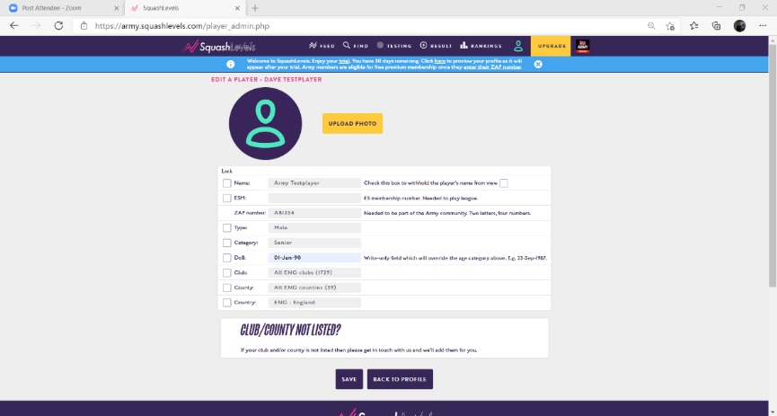

Step 4 - Enter your Corps and Locality from the dropdown and SAVE

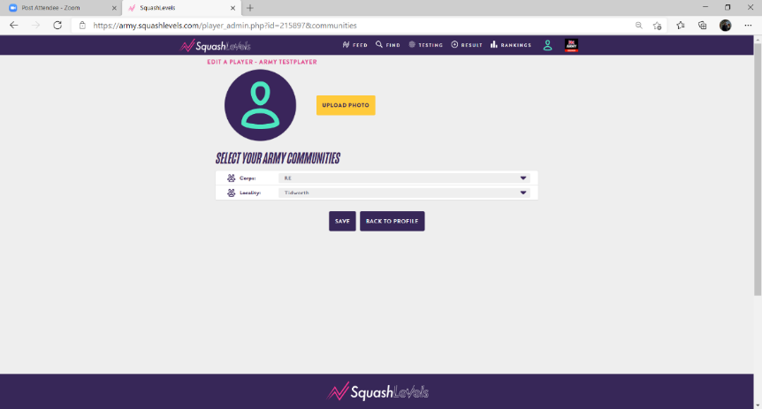

Well done you are now registered on Squash Levels and the Army Squash
community, your Corps sub-community and your Army location sub-community
and should see a summary page. Click Feed for the Army Squash dashboard
which will provide more information on how to make the most of your Squash
Levels membership. Ellipsis also highlighted to change profile.

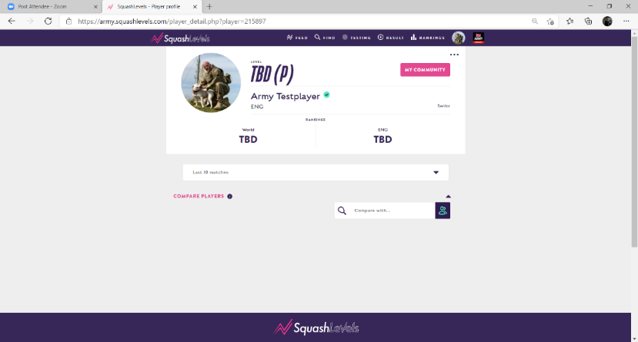

Here is the link that takes you straight to the Army Squash Community Page.
Any problems with registration contact the AS Sec via email dcampey@ascb.uk.com

